**KWAME NKRUMAH UNIVERSITY OF SCIENCE AND TECHNOLOGY**

**CHEMICAL ENGINEERING DEPARTMENT**

**CHE 158: INTRODUCTION TO INFORMATION TECHNOLOGY**

**INSTRUCTOR:** Dr. (Mrs.) Mizpah A. D. Rockson

LECTURE 8: **SECONDARY STORAGE**

**Learning Objectives**

At the end of the lecture the student is expected to be able to do the following:

1. Distinguish between primary and secondary storage.
2. Identify the important characteristics of secondary storage including media, capacity, storage devices, and access speed.
3. Describe hard-disk platters, tracks, sectors, cylinders, and head crashes.
4. Compare internal and external hard drives.
5. Compare performance enhancements including disk caching, RAID, file compression, and file decompression.
6. Define optical storage including compact discs, digital versatile discs, and Blu-ray discs.
7. Define solid-state storage including solid-state drives, flash memory cards, and USB drives.
8. Define cloud storage and cloud storage services.
9. Describe mass storage, mass storage devices, enterprise storage systems, and storage area networks.

**8.0 Introduction**

Secondary storage devices are used to save, to back up, and even to transport files consisting of data or programs from one location or computer to another. At one time, almost all files contained only numbers and letters. The demands for saving these files were easily met with low-capacity storage devices (floppy and hard disk drives).

Data storage has expanded from text and numeric files to include digital music files, photographic files, video files, and much more. These new types of files require secondary storage devices that have much greater capacity.

Secondary storage devices have always been an indispensable element in any computer system. They have similarities to output and input devices. Like output devices, secondary storage devices receive information from the system unit in the form of the machine language of 0s and 1s. Rather than translating the information, however, secondary storage devices save the information in machine language for later use. Like input devices, secondary storage devices send information to the system unit for processing. However, the information, since it is already in machine form, does not need to be translated. It is sent directly to memory (RAM), where it can be accessed and processed by the CPU.

**8.1 Storage**

**Secondary storage** provides permanent or nonvolatile storage. Using **secondary storage devices** such as a hard disk drive, data and programs can be retained after the computer has been shut off. This is accomplished by *writing* files to and *reading* files from secondary storage devices. **Writing** is the process of saving information *to* the secondary storage device. **Reading** is the process of accessing information *from* secondary storage. This chapter focuses on secondary storage devices.

Some important characteristics of secondary storage include:

* **Media** are the actual physical material that holds the data and programs.

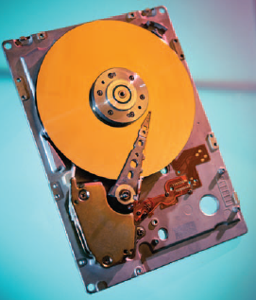

**Figure 8.1: Secondary storage media**

* **Capacity** measures how much a particular storage medium can hold.
* **Storage devices** are hardware that reads data and programs from storage media. Most also write to storage media.
* **Access speed** measures the amount of time required by the storage device to retrieve data and programs.

Most desktop microcomputer systems have hard and optical disk drives, as well as ports where additional storage devices can be connected.

**8.2 Hard disks**

Hard disks save files by altering the magnetic charges of the disk’s surface to represent 1s and 0s. Hard disks retrieve data and programs by reading these charges from the magnetic disk.

Characters are represented by positive (+) and negative (−) charges using the ASCII, EBCDIC, or Unicode binary codes.

**Density** refers to how tightly these charges can be packed next to one another on the disk.

**Hard disks** use rigid metallic **platters** that are stacked one on top of another. Hard disks store and organize files using tracks, sectors, and cylinders.

**Tracks** are rings of concentric circles without visible grooves. Each track is divided into invisible wedge-shaped sections called **sectors.**

A **cylinder** runs through each track of a stack of platters. Cylinders are necessary to differentiate files stored on the same track and sector of different platters. When a hard disk is formatted, tracks, sectors, and cylinders are assigned. Hard disks are sensitive instruments. Their read/write heads ride on a cushion of air about 0.000001 inch thick. It is so thin that a smoke particle, fingerprint, dust, or human hair could cause what is known as a head crash.

A **head crash** occurs when a read/write head makes contact with the hard disk’s surface or with particles on its surface. A head crash is a disaster for a hard disk. The disk surface is scratched and some or all of the data is destroyed. At one time, head crashes were commonplace.

Now, fortunately, they are rare. There are two basic types of hard disks: internal and external.

**8.2.1 Internal hard disk**

An **internal hard disk** is located inside the system unit. These hard disks are able to store and retrieve large quantities of information quickly. For example, nearly every microcomputer uses its internal hard disk to store its operating system and major applications such as Word and Excel.

To ensure adequate performance of your internal hard disk and the safety of your data, you should perform routine maintenance and periodically make backup copies of all important files.

**8.2.2 External hard disk**

While internal hard disks provide fast access, they have a fixed amount of storage and cannot be easily removed from the system cabinet. External hard disks typically connect to a USB or FireWire port on the system unit, are easily removed, and effectively provide an unlimited amount of storage.

**8.2.3 Performance enhancement**

Three ways to improve the performance of hard disks are disk caching, redundant arrays of inexpensive disks, and file compression/decompression.

**Disk caching** improves hard-disk performance by anticipating data needs. It performs a function similar to cache memory. While cache memory improves processing by acting as a temporary high-speed holding area between memory and the CPU, disk caching improves processing by acting as a temporary high-speed holding area between a secondary storage device and the CPU. Disk caching requires a combination of hardware and software. During idle processing time, frequently used data is read from the hard disk into memory (cache). When needed, the data is then accessed directly from memory. The transfer rate from memory is much faster than from the hard disk. As a result, overall system performance is often increased by as much as 30 percent.

**Redundant arrays of inexpensive disks (RAID)** improve performance by expanding external storage, improving access speed, and providing reliable storage. Several inexpensive hard-disk drives are connected to one another. These connections can be by a network or within specialized RAID devices. The connected hard-disk drives are related or grouped together, and the computer system interacts with the RAID system as though it were a single large-capacity hard-disk drive. The result is expanded storage capability, fast access speed, and high reliability. For these reasons, RAID is often used by Internet servers and large organizations.

**File compression** and **file decompression** increase storage capacity by reducing the amount of space required to store data and programs. File compression is not limited to hard-disk systems. It is frequently used to compress files on DVDs, CDs, and flash drives as well. File compression also helps to speed up transmission of files from one computer system to another. Sending and receiving compressed files across the Internet is a common activity.

File compression programs scan files for ways to reduce the amount of required storage. One way is to search for repeating patterns. The repeating patterns are replaced with a token, leaving enough tokens so that the original can be rebuilt or decompressed. These programs often shrink files to a quarter of their original size.

You can compress and decompress files using specialized utilities such as WinZip. Or, if a specialized utility is not available, you can use utility programs in Windows.

**8.3 Optical discs**

In optical-disc technology, a laser beam alters the surface of a plastic or metallic disc to represent data. Unlike hard disks, which use magnetic charges to represent 1s and 0s, optical discs use reflected light. The 1s and 0s are represented by flat areas called **lands** and bumpy areas called **pits** on the disc surface. The disc is read by an **optical disc drive** using a laser that projects a tiny beam of light on these areas. The amount of reflected light determines whether the area represents a 1 or a 0. Like hard disks, optical discs use tracks and sectors to organize and store files. Unlike the concentric tracks and wedge-shaped sectors used for hard disks, however, optical discs typically use a single track that spirals toward the center of the disc. This single track is divided into equally sized sectors.

**8.3.1 Compact disc**

**Compact disc,** or **CD** is one of the most widely used optical formats. CD drives are standard on many microcomputer systems. Typically, CD drives can store from 650 MB (megabytes) to 1 GB (gigabyte) of data on one side of a CD.

There are three basic types of CDs: read only, write once, and rewritable:

* **Read only— CD-ROM,** which stands for **compact disc–read-only memory,** is similar to a commercial music CD. *Read only* means it cannot be written on or erased by the user. Thus, you as a user have access only to the data imprinted by the publisher. CD-ROMs are used to distribute large databases and references. They also are used to distribute large software application packages.
* **Write once— CD-R,** which stands for **CD recordable,** can be written to once. After that they can be read many times without deterioration but cannot be written on or erased. CD-R drives often are used to archive data and to record music downloaded from the Internet.
* **Rewriteable— CD-RW** stands for **compact disc rewritable.** Also known as **erasable optical discs,** these discs are very similar to CD-Rs except that the disc surface is not permanently altered when data is recorded. Because they can be changed, CD-RWs are often used to create and edit multimedia presentations.

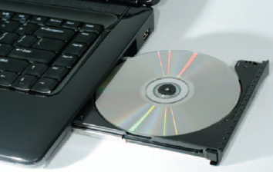

**Figure 8.2: Optical disc**

**8.3.2 Digital versatile disc**

**DVD** stands for **digital versatile disc** or **digital video disc.** This is a newer format that has replaced CDs asthe standard optical disc. DVDs are very similar to CDsexcept that more data can be packed into the sameamount of space. DVD discs can store4.7 GB to 17 GB on a single DVD disc—17 times thecapacity of CDs. There are three basic types of DVDs,similar to CDs: read only, write once, and rewriteable.

* **Read only— DVD-ROM** stands for **digital versatile disc–read-only memory.** DVD-ROM drives are also known as **DVD players.** DVD-ROMs are having a major impact on the video market. While CD-ROMs are effective for distributing music, they can only contain just over an hour of fair-quality video. DVD-ROMs can provide over two hours of high-quality video and sound comparable to that found in motion picture theaters. The motion picture industry has rapidly shifted video distribution from video cassettes to DVD-ROMs.
* **Write once—DVD** + **R** and **DVD** − **R** are two competing write-once formats. Both stand for **DVD recordable.** Each has a slightly different way in which it formats its discs. Fortunately, most new DVD players can use either format. These drives are typically used to create permanent archives for large amounts of data and to record videos. DVD recordable drives are rapidly replacing CD-R drives due to their massive capacity.
* **Rewriteable—DVD** + **RW, DVD** − **RW,** and **DVD-RAM** are the three most widely used formats. DVD + RW and DVD − RW stand for **DVD rewriteable. DVD-RAM** stands for **DVD random-access memory.** Each format has a unique way of storing data. Unfortunately, older DVD players typically can read only one type of format. Newer DVD players, however, are able to read and use any of the formats. Rewriteable DVD disc drives have rapidly replaced CD rewriteable drives. Applications range from recording video from camcorders to developing multimedia presentations that include extensive graphics and video.

**8.3.3 Blu-ray disc**

While CDs and DVDs are the most widely used optical discs today, the future belongs to discs of even greater capacity. While DVD discs have sufficient capacity to record standard-definition movies and music, they are insufficient for recording high-definition video, which requires about four times as much storage. This next generation of optical disc is called **hi def** **(high definition),** with a far greater capacity than DVDs. The hi def standard is **Blu-ray Disc (BD).** The name comes from the blue-colored laser that is used to read the disc. Blu-ray Discs have a capacity of 25 to 100 gigabytes, more than 20 times the capacity of a standard single-layer DVD. Although Blu-ray media are the same size as other optical media, the discs require special drives. Most of these drives are capable of reading standard DVDs and CDs in addition to Blu-ray.

Like CDs and DVDs, Blu-ray has three basic types: read only, write once, and rewriteable.

**8.4 Solid-state storage**

Unlike hard disks, which rotate and have read/write heads that move in and out, **solid-state storage** devices have no moving parts. Data and information are stored and retrieved electronically directly from these devices much as they would be from conventional computer memory.

**8.4.1 Solid-state drives**

**Solid-state drives (SSDs)** are designed to be connected inside a microcomputer system the same way an internal hard disk would be but contain solid state memory instead of magnetic disks to store data.

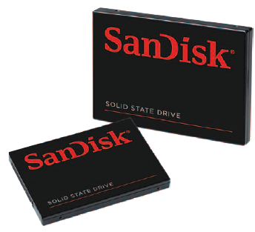

**Figure 8.3: Solid-state storage**

SSDs are faster and more durable than hard disks. SSDs also require less power, which can lead to increased battery life for laptops and mobile devices. SSDs are more expensive and generally have a lower capacity than hard disks, but this is changing as the popularity of SSDs continues to increase.

**8.4.2 Flash memory**

**Flash memory cards** are small solid-state storage devices widely used in portable devices such as mobile phones and GPS navigation systems.

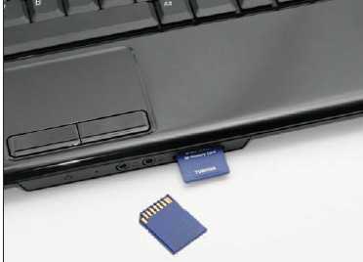

**Figure 8.4: Flash memory cards**

Flash memory also is used in a variety of specialized input devices to capture and transfer data to desktop computers. For example, flash memory is used to store images captured from digital cameras and then to transfer the images to desktop and other computers. Flash memory is used in digital media players like the iPod to store and play music and video files.

**8.4.3 USB drives**

**USB drives,** or **flash drives,** are so compact that they can be transported on a key ring. These drives conveniently connect directly to a computer’s USB port to transfer files and can have capacities ranging from 1 GB to 256 GB, with a broad price range to match. Due to their convenient size and large capacities, USB drives have become a very popular option for transporting data and information between computers, specialty devices, and the Internet.

**8.5 Cloud storage**

When one is online, he has the ability to use the server’s storage devices for transferring or processing information.

The processing power of the service provider’s server is used to run the applications and your local computer is responsible only for displaying the results. The applications and data can be accessed from any Internet-ready device. This means that even devices with little storage, memory, or processing power, such as mobile phones, can run the same powerful applications as a desktop computer. The benefits to this arrangement are numerous. It saves time. With software delivered from the cloud as a service, a company can simply purchase the appropriate number of accounts from the service provider and direct employees to use the provider’s Web site.

**8.6 Mass storage devices**

**Mass storage** refers to the tremendous amount of secondary storage required by large organizations. **Mass storage devices** are specialized high-capacity secondary storage devices designed to meet organizational demands for data.

**8.6.1 Enterprise storage system**

Most large organizations have established a strategy called an **enterprise storage system** to promote efficient and safe use of data across the networkswithin their organizations. Some of the mass storage devicesthat support this strategy are

* **File servers** —dedicated computers with very large storage capacities that provide users access to fast storage and retrieval of data.
* **Network attached storage (NAS)** —similar to a file server except simpler and less expensive; widely used for home and small business storage needs.
* **RAID systems** —larger versions of the specialized devices discussed earlier in this chapter that enhance organizational security by constantly making backup copies of files moving across the organization’s networks.
* **Tape library** —device that provides automatic access to data archived on a library of tapes.
* **Organizational cloud storage** —high-speed Internet connection to a dedicated remote organizational cloud storage server.

**8.6.2 Storage area network**

A recent mass storage development is **storage area network (SAN)** systems. SAN is an architecture to link remote computer storage devices, such as enterprise storage systems, to computers such that the devices are as available as locally attached drives. In a SAN system, the user’s computer provides the file system for storing data, but the SAN provides the disk space for data.

The key to a SAN is a high-speed network, connecting individual computers to mass storage devices. Special file systems prevent simultaneous users from interfering with each other. SANs provide the ability to house data in remote locations and still allow efficient and secure access.

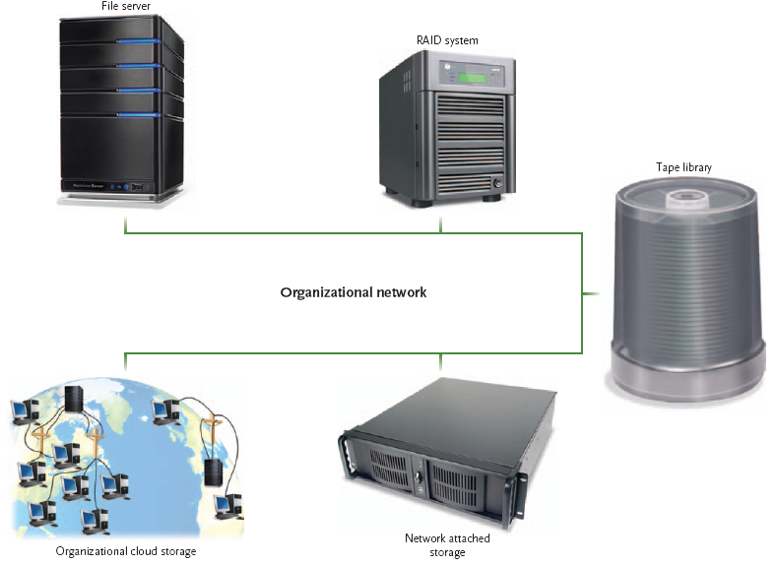

**Figure 8.5: Enterprise storage system**